DENTAL HISTORY
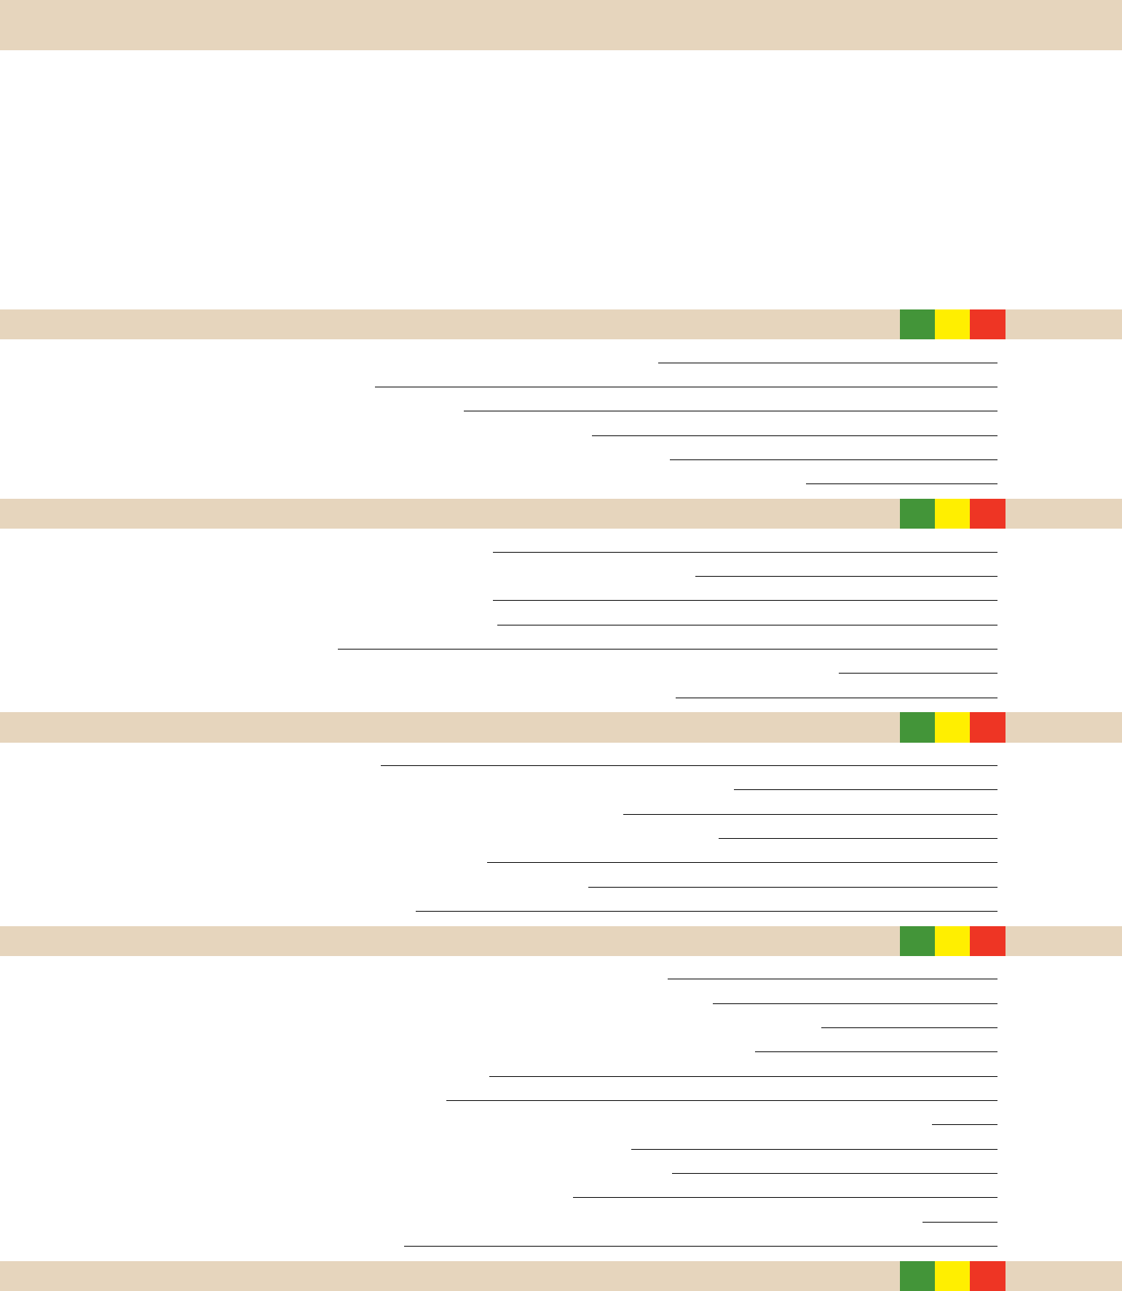

Patient Name |  |  |  |  | Nickname |  |  | Age
Referred by |  |  |  |  | How would you rate the condition of your mouth? Excellent |  |  | Good Fair |  | Poor
Previous Dentist |  |  |  |  | How long have you been a patient? |  |  | Months/Years
Date of most recent dental exam ____ /____ /____ Date of most recent x-rays ___ /____ /____
Date of most recent treatment (other than a cleaning) ____ /____ /____
I routinely see my dentist every |  |  |  | 3 mo. 4 mo. 6 mo. 12 mo. Not routinely
WHAT IS YOUR IMMEDIATE CONCERN?
PLEASE ANSWER YES OR NO TO THE FOLLOWING:
PERSONAL HISTORY |  |  |  |  |  |  |  |  | YES | NO

- Are you fearful of dental treatment? How fearful, on a scale of 1 (least) to 10 (most) [____]

- Have you had an unfavorable dental experience?

- Have you ever had complications from past dental treatment?

- Have you ever had trouble getting numb or had any reactions to local anesthetic?

- Did you ever have braces, orthodontic treatment or had your bite adjusted, and at what age?

- Have you had any teeth removed, missing teeth that never developed or lost teeth due to injury or facial trauma?

GUM AND BONE YES NO

- Do your gums bleed or are they painful when brushing or flossing?

- Have you ever been treated for gum disease or been told you have lost bone around your teeth?

- Have you ever noticed an unpleasant taste or odor in your mouth?

- Is there anyone with a history of periodontal disease in your family?

- Have you ever experienced gum recession?

- Have you ever had any teeth become loose on their own (without an injury), or do you have difficulty eating an apple?

- Have you experienced a burning or painful sensation in your mouth not related to your teeth?

TOOTH STRUCTURE YES NO

- Have you had any cavities within the past 3 years?

- Does the amount of saliva in your mouth seem too little or do you have difficulty swallowing any food?

- Do you feel or notice any holes (i.e. pitting, craters) on the biting surface of your teeth?

- Are any teeth sensitive to hot, cold, biting, sweets, or do you avoid brushing any part of your mouth?

- Do you have grooves or notches on your teeth near the gum line?

- Have you ever broken teeth, chipped teeth, or had a toothache or cracked filling?

- Do you frequently get food caught between any teeth?

BITE AND JAW JOINT YES NO

- Do you have problems with your jaw joint? (pain, sounds, limited opening, locking, popping)

- Do you feel like your lower jaw is being pushed back when you try to bite your back teeth together?

- Do you avoid or have difficulty chewing gum, carrots, nuts, bagels, baguettes, protein bars, or other hard, dry foods?

- In the past 5 years, have your teeth changed (become shorter, thinner, or worn) or has your bite changed?

- Are your teeth becoming more crooked, crowded, or overlapped?

- Are your teeth developing spaces or becoming more loose?

- Do you have trouble finding your bite, or need to squeeze, tap your teeth together, or shift your jaw to make your teeth fit together?

- Do you place your tongue between your teeth or close your teeth against your tongue?

- Do you chew ice, bite your nails, use your teeth to hold objects, or have any other oral habits?

- Do you clench or grind your teeth together in the daytime or make them sore?

- Do you have any problems with sleep (i.e. restlessness or teeth grinding), wake up with a headache or an awareness of your teeth?

- Do you wear or have you ever worn a bite appliance?

SMILE CHARACTERISTICS |  |  |  |  |  |  |  |  |  | YES | NO
33. | Is there anything about the appearance of your teeth that you would like to change (shape, color, size)?
34. | Have you ever whitened (bleached) your teeth?
35. | Have you felt uncomfortable or self conscious about the appearance of your teeth?
36. | Have you been disappointed with the appearance of previous dental work?
Patient’s Signature |  |  |  |  |  |  |  | Date
Doctor’s Signature |  |  |  |  |  |  |  | Date

© 2018 Kois Center, LLC www.koiscenter.com

